«IGROMIR 2018» & COMIC CON RUSSIA 2018 EXHIBITOR'S GUIDE

Dear Participants!

The Exhibition Management of Igromir 2018 and Comic Con Russia 2018 welcomes you as an official participant of the event. Please read the information you need in order to prepare for the exhibition.

The Exhibition Management stands ready to provide any additional help and support in organisational matters.

We wish you success!

«KRI» LTD
«Igromir 2018»
& Comic Con Russia 2018
Exhibition Management

TABLE OF CONTENTS:

CONTACTS OF THE EXHIBITION MANAGEMENT……………….……….  1. PERIOD OF THE DOCUMENTATION SUPPLY……..............................  2. EXHIBITION DATES & HOURS..................……………...……...………….  3. PARTICIPATION FEE ………………………………………………………….….  4. BOOTH CONSTRUCTION…………..…………………………….……............  5. ARRIVAL TO THE EXHIBITION…………………………………..…………….  6. PAVILION ACCESS FOR EXHIBITORS……………………………………….  7. PARTICIPANT BADGES………………………..………………………………….  8. COMPLIMENTARY TICKETS ……………………………………………..……..  9. SECURITY……………………………………….……………..……………………..  10. VOLUME OF THE SOUND EQUIPMENT AT THE EXHIBITION………....  11. BOOTH POWER CONSUMPTION..…………..…..................................  12. THE INTERNET CONNECTION…………..…………………………………....  13. PERSONAL BOOTH CLEANING…………………………………………………  14. ADDITIONAL SERVICES…………………………………………………..……  FORM 1 Sample Letter permitting delivery/removal and installation/dismantling of equipment and exhibits ………………………  FORM 2 Sample letter for the exhibitor's badges …………..…………  FORM 3 Sample letter for free complimentary tickets to the exhibition………………………………………….........................................  FORM 4 Request for additional electricity….....................................  FORM 5 Request for Internet connection……………………………….. | p. 3  p. 4  p. 5  p. 7  p. 8  p. 9  p. 10  p. 11  p. 12  p. 13  p. 14  p. 15  p. 16  p. 17  p. 18  p. 19  p. 20  p. 21  p. 22  p. 23

«IGROMIR 2018» EXHIBITION
«COMIC CON RUSSIA 2018» EXHIBITION

CONTACTS

POSITION | Name / Last Name | Tel: | E-mail
General Director  «KRI» LTD | Yulia Shkileva | (903) 199 03 90 | sales@igromir-expo.ru
Leading specialist | Tatiana Seliverova | (926) 474-04-34 | tintal@kriconf.ru
Chief Accountant «KRI» LTD | Svetlana Yakovleva | Tel/Fax:  (499) 922 66 78
«Igromir 2018» & Comic Con Russia 2018  Booth construction issues | Denis Vaskin | (985) 969 66 38 | vaskind@mail.ru
Booth construction — accreditation of third-party developers | ООО «BildEkspo»  Technical department  Chief Engineer Alexander Trofimov | (495) 727-26-71  (495) 727-26-72

1. PERIOD OF THE DOCUMENTATION SUPPLY

DOCUMENT NAME | DOCUMENT FORMAT | DOCUMENT SUBMISSION TIME LIMITS
Sample Letter permitting delivery/removal and installation/dismantling of equipment and exhibits | Form 1 | When delivering the equipment / exhibits (in 3 copies)
Sample letter for the exhibitor's badges | Form 2 | till September, 20th, 2018
Sample letter for free complimentary tickets to the exhibition | Form 3 | till September, 20th, 2018
Request for additional electricity | Form 4 | till September, 11th, 2018
Request for Internet connection | Form 5 | till September, 11th, 2018

2. «IGROMIR 2018» & COMIC CON RUSSIA 2018 EXHIBITION DATES & HOURS

The exhibition takes places at:
143402, Moscow region, Krasnogorsk
65-66 km MKAD
«Crocus Expo» Exhibition Complex
Pavilion 1

«Igromir 2018» Exhibition: halls 3 and 4
«Comic Con Russia 2018» Exhibition: halls 1 and 2
Business area: Pavilion 1, Conference hall 3/4

«Igromir 2018» installation, halls 3 and 4 September, 30th – October 3rd
September, 30th: from 12.00 to 20.00
October 1st, – October, 3rd: from 08.00 to 20.00
«Comic Con Russia 2018» installation, halls 1 and 2:
October 1st: from 12.00 to 20.00
October 2nd, – October, 3rd: from 08.00 to 20.00
Business area installation, pavilion 1, conference hall 3/4: October 3rd:
08.00 - 16.00
Equipment set-up (in all halls, excluding conference hall 3/4, with no possibility of installation and construction works): October, 3rd: from 20.00 to 22.00

Arrival hours for the “Comic Con Russia” shopping area participants:
October, 3rd, from 10.00 to 18.00

Arrival hours for the business area participants (conference hall №3/4):
October, 3rd, from 16.00 to 18.00

«Igromir 2018» and «Comic Con Russia 2018» Working hours:
October 4th (business day): 11.00 – 18.00
October 5th – 6th: 09.30 – 18.30
October 7th: 09.30 – 17.30

Business area working hours:
October 4th – October 6th
October 4th: 11.00 – 18.00
October 5th: 10.00 – 18.00
October 6th: 10.00 – 16.00

«Igromir 2018» & «Comic Con Russia 2018» exhibition dismantling in halls 1, 2, 3, 4:
October, 7th – October, 8th
October, 7th: 18.00 — 20.00 (only equipment and exhibits dismantling)
October, 8th: 08.00 — 20.00

Business area dismantling:
October 6th
October 6th: 16.00 — 20.00

Driving directions:

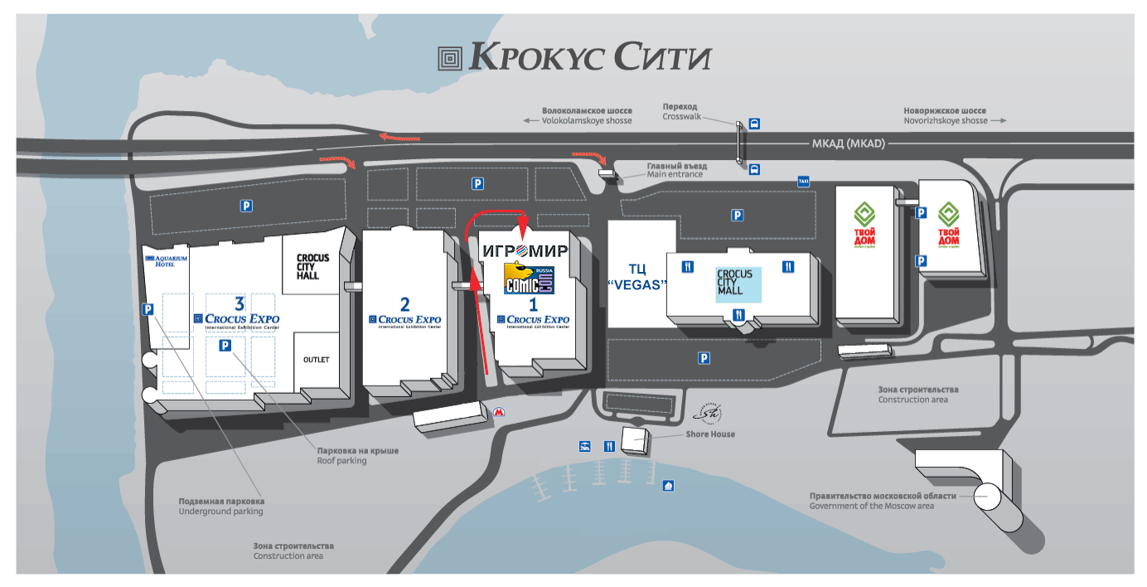

3. «IGROMIR 2018»
& COMIC CON RUSSIA 2018 PARTICIPATION FEE

In matters regarding invoices, booth rent, and agreement processing, please contact the Igromir 2018 General Director: Seliverova Tatiana, tel.: (926) 474-04-34.

In matters regarding the exchange of signed copies of documents and the receipt of closing documents, please contact the “KRI” LTD General Director: Shkileva Yulia, tel.: (903) 199-0390.

In accordance with your order, (additional services request form: extra staff badges, extra complimentary tickets, advertising services e.t.c.) you may be invoiced for additional services.

All invoices must be paid within the specified time period and the payment order must be presented to “KRI” LTD (A copy of the payment order must be sent to the accountant via fax: (499) 922-6678).

In case of a violation of the venue rent payment time limits, “KRI” LTD has a right to cancel your participation in the «Igromir 2018” exhibition and/or Comic Con Russia 2018 in accordance with p. 3.3. of a standart exhibition participation agreement.

The access to installation and decoration works is granted to the exhebitors only after full venue rent payment and any additional payments reaches the account of “KRI” LTD.

Please note that the exhibition closing documents can be received only after the end of the event.

In case of ordering additional services three days prior to the commencement of the installation works and later, the final settlement for participation in the exhibition is performed within 7 working days after the end of the dismantling works.

Please note that in case of ordering additional services three days prior to the commencement of the installation works and later, the closing documents are issued only after full payment for the additional services reaches the account of “KRI” LTD.

4. «IGROMIR 2018» И COMIC CON RUSSIA 2018 BOOTH CONSTRUCTION

Booth construction coordinator

In matters regarding booth construction, please contact the exhibition construction coordinator:

Project coordinator:
Denis Vaskin
Tel. +7 (495) 969-6638
E-mail: vaskind@mail.ru

Information for third party developers

«BildEkspo» LTD is the general developer of the "Crocus Expo" exhibition complex. Therefore, in order to be able to carry out the booth construction works, please meet the following requirements:

1. No later than 14 days before the opening of the exhibit, contact the technical depatment of “BildEkspo” LTD via tel. (495) 727-26-71, (495) 727-26-72 on the issue of verification of technical documentation and access to exhibition areas.

2. Enter into a contract with “BildEkspo” LTD for the verification of technical documentation and an agreement for the execution of electrical measurements.

It is necessary to bring bank account details and a company stamp.
All documents have to be submitted in original or in a certified copy.

Installation and dismantling period

«Igromir 2018» installation, halls 3 and 4 September, 30th – October 3rd
September, 30th: from 12.00 to 20.00
October 1st, – October, 3rd: from 08.00 to 20.00
«Comic Con Russia 2018» installation, halls 1 and 2:
October 1st: from 12.00 to 20.00
October 2nd, – October, 3rd: from 08.00 to 20.00
Business area installation, pavilion 1, conference hall 3/4: October 3rd: 08.00 - 16.00
Equipment set-up (in all halls, excluding conference hall 3/4, with no possibility of installation and construction works): October, 3rd: from 20.00 to 22.00

«Igromir 2018» & «Comic Con Russia 2018» exhibition dismantling in halls 1, 2, 3, 4:
October, 7th – October, 8th
October, 7th: 18.00 — 20.00 (only equipment and exhibits dismantling)
October, 8th: 08.00 — 20.00

Business area dismantling:
October 6th
October 6th: 16.00 — 20.00

Attention! Due to the shortened installation period in Conference hall of the 3/4 business zone, engagement of third-party contractors is not permitted. The installation works in business area shall be performed by “BildEkspo” LTD only.
5. ARRIVAL TO THE EXHIBITIONS: «IGROMIR 2018» & COMIC CON RUSSIA 2018

1. Admission of participants’ and developers’ or contractors’ vehicles to the area of loading and unloading (including the mounting gates of Pavilion 1) is paid.

The cost of one pass per a vehicle (the pass is valid for all days of installation and dismantling):

Light vehicle: 2500 rur
Cargo vehicle: 5500 rur

The pass must be acquired at the Service center of Pavilion 1 on the days of installation / dismantling of the exhibition from 09.00 to 7:00 p.m.

Regular vehicle residence time in the loading and unloading area:

For a light vehicle: 1 hour
For a cargo vehicle: 2 hours

2. A list of equipment/exhibits must be available in 3 copies at the time of moving-in for the move-in/removal of the booth equipment and exhibits (see Form 1 in this guide). The list must be certified by the stamp pf the Directorate at the registration counter in Pavilion 1, and one copy must be handed in at the Service center of Pavilion 1.

Attention: The import of equipment and exhibits is implemented strictly on the following schedule:

Installation/Dismantling days: from 8:00 am to 8:00 pm.
Exhibition days: from 8:00 am to 09.30 am and from 6:30 to 7:30 pm.

Be careful – during the days of the exhibition, the import of equipment and exhibits to the pavilion from 09:30 a.m. to 6:30 p.m. is not permitted.

Attention: The delivery of equipment and exhibits proceeds on the basis of documents issued by the exhibiting company or by an accredited developer. Equipment and exhibits on documents from companies that are not exhibiting or from a non-accredited developer are not allowed!
6. PAVILION ACCESS FOR THE EXHIBITORS OF IGROMIR 2018 & COMIC CON RUSSIA 2018

Access to the pavilion during the installation/dismantling of the "Igromir 2018" and Comic Con Russia 2018 exhibitions is implemented by participant badges (see section 7 of this guide) and the mounting passes. The mounting passes are issued by the "Crocus Expo" general developer, “BildEkspo” LTD, when the stand is accredited.

Access to the pavilion during the exhibition days is implemented by participant badges in the following schedule only:

October 4th – October 7th: from 08.00 am to 20.00 pm.

ATTENTION:
Due to the fact, that the Igromir 2018 and Comic Con Russia 2018 are mass events, a large number of visitors is expected to visit the both exhibitions from October 4th – October 7th (from Friday to Sunday inclusively). For your convenience and in order to reduce the load on the main entrance to Pavilion 1, the exhibition will be provided with two VIP entrances for exhibitors from October 4th – October 7th:

VIP-entrance № 1 – main entrance to pavilion 2, then to the 2 floor to food court, and then to the cross-pavilion passage to pavilion 1

VIP-entrance № 2 – main entrance to pavilion 1, left part of the entrance group

DEAR EXHIBITORS! IT IS RESPECTFULLY REQUESTED THAT YOU USE THE VIP ENTRANCE # 1 IN THE MORNING HOURS FROM OCTOBER 4th TO OCTOBER 7th 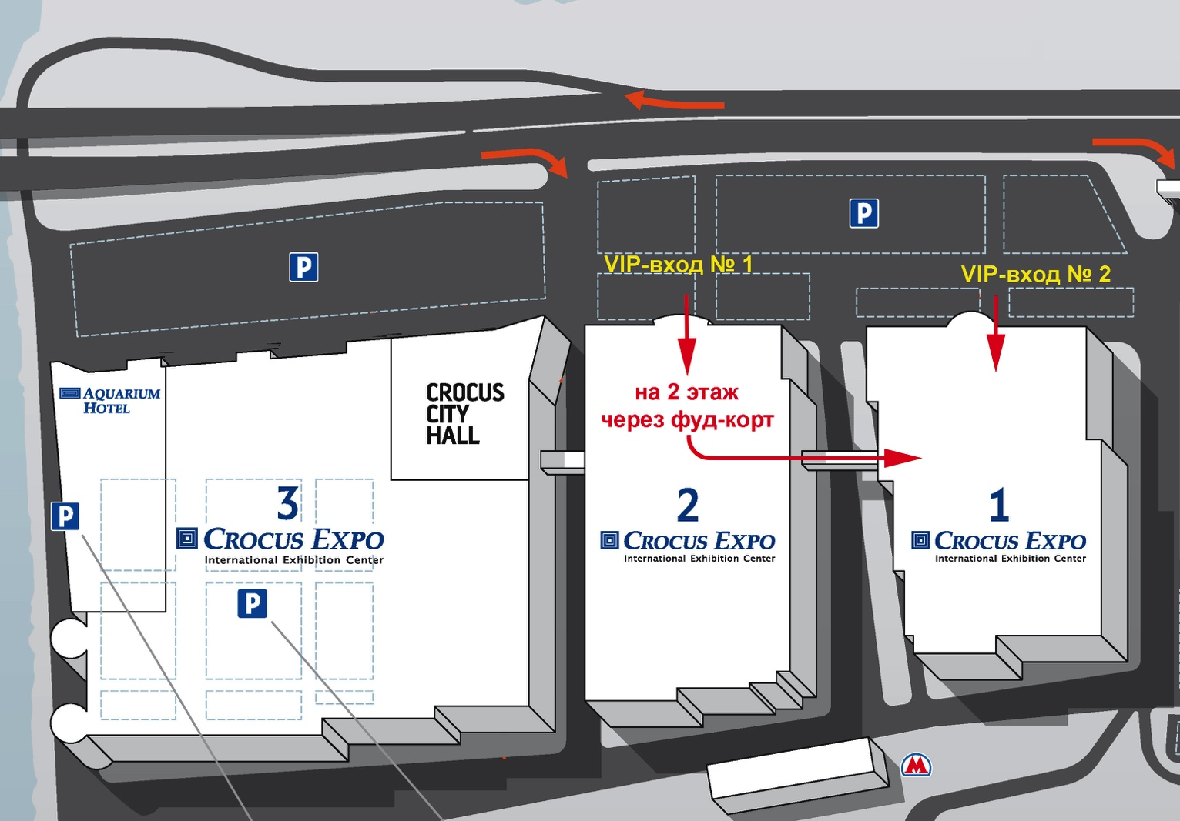

7. «IGROMIR 2018» & COMIC CON RUSSIA 2018 PARTICIPANT BADGES

Exhibitor's badge issuance for the «Igromir 2018» и Comic Con Russia 2018 participants:

Thу Igromir 2018 and Comic Con Russia 2018 participants’ name badges are issued at the rate of 1 badge for every 2 sq.m. of the booth area.

Badges for trading places at the Comic Con Russia are allocated as follows:

- trading place: 2 badges
- point of sales 3 sq m: 3 badges
- booth in the trading zone 4 sq m: 4 badges
- booth in the trading zone 8 sq m: 5 badges

Additional badges can be acquired from the Exhibition Management by cashless (pre-order is necessary) or cash (during the installation works or the exhibition days) payment. Price for the additional badges as follows:

2000 rur per piece, including 18% VAT (in case of advance cashless payment); 3000 rur per piece, including 18% VAT (in case of cash payment during the exhibition).

Name badges are issued by the Exhibition Management from October 1st, 2018 provided 100% of venue rent is paid.

Exhibitor's name badge:

Admission to the exhibition territory during the installation/dismantling of the "Igromir 2018" and Comic Con Russia 2018 exhibitions is implemented by participant badges (see section 7 of this guide) and the mounting passes.

In order to recieve the badges, the exhibitors must prepare the following documents until September, 25th, 2018:

1. A letter to the General Director of «KRI» LTD on the letterhead of the exhibitor's company, signed and sealed by the General Manager of the company (Form 2).

2. A list of participants (an Excel document specifying certain details, such as: name, last name, position, name of the company – on separate fields) that has to be sent via tintal@kriconf.ru

The list must be submitted in the following format only:
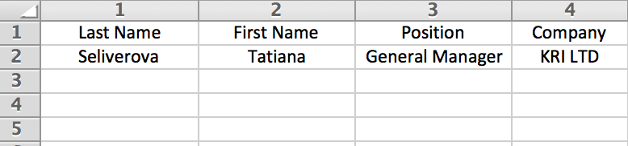

ATTENTION!
Please remember to bring name badges with you – exhibitors without badges are not allowed to enter the territory of «Igromir» and «Comic Con Russia» in pavilion 1.

Badges are the property of «Igromir» and «Comic Con Russia» exhibition management. Badges without photo-identification (ID) are invalid. Badge-Sharing is not allowed.

ID must be presented at the request of the security service or the exhibition management. If badge owner does not present ID or the name on his/her badge does not match the name in his/her ID, the badge will be removed, and the participant may be expelled from the exhibition.

In this case, the duplicate is issued on a for-fee basis after the exhibitor’s official request to the exhibition management only.

8. «IGROMIR 2018» & COMIC CON RUSSIA 2018 COMPLIMENTARY TICKETS

The complimentary tickets to the Igromir 2018 and Comic Con Russia 2018 are divided into two types: complimentary tickets for the business day (October, 4th) and complimentary tickets for visiting both of the exhibitions from October 5th to October, 7th.

1. Complimentary tickets for the business day of «Igromir 2018» and «Comic Con Russia 2018»

The business day complimentary tickets are valid within October 4th at the “Igromir 2018” and “Comic Con Russia 2018” exhibitions. The business day complimentary tickets are issued in the requested quantity by the exhibitor’s official letter addressed to the General Director of “KRI” LTD, Yulia Shkileva (Form 3). Please note, that the business day of Igromir and Comic Con is organised in order to provide business and media communication. The exhibitors are kindly asked to follow this rule and not to distribute the business day tickets among the gaming products consumers.

2. Complimentary tickets for the «Igromir 2018» & Comic Con Russia 2018 (October 5th to October, 7th)

Complimentary tickets for Igromir 2018 & Comic Con Russia 2018 (October 5th to October, 7th) are vaild throughout one day of the exhibition only. Complimentary tickets for Igromir 2018 & Comic Con Russia 2018 (October 5th to October, 7th) are issued to the exhibiting company by the exhibitor’s official letter addressed to the General Director of “KRI” LTD, Yulia Shkileva (Form 3). The normative issuance rate for Igromir 2018 & Comic Con Russia 2018 complimentary tickets (October 5th to October, 7th)is 1 ticket for each 5 sq.m. of the booth area. Additional complimentary tickets for Igromir 2018 & Comic Con Russia 2018 (October 5th to October, 7th) can be acquired from the Exhibition Management by cashless (pre-order is necessary) or cash (during the installation works or the exhibition days) payment. The cost of ordering additional complimentary tickets for Igromir 2018 & Comic Con Russia 2018 (October 5th to October, 7th) for the exhibiting participants renting a booth: 600 rur per ticket, including 18% VAT.

The issuance of the complimentary tickets is implemented in the Directorate of the exhibition after the letter of invitation has been processed and (if the tickets are ordered above the prescribed rate) after the 100% of payment has reached the account of “KRI” LTD from September, 28th, 2018.

9. «IGROMIR 2018» & COMIC CON RUSSIA 2018 SECURITY
The venue rental rent includes the cost of the general security of the pavilion at night and during the installation/dismantling days.

In order to ensure the security of the small exhibits, which are not placed in closed showcases, we offer you to ensure the presence of an employee of your company at the booth during installation after the delivery of the exhibits and during the exhibition period (October 4th – October 7th) from 08-00 to 09-30 am and from 18-30 to 20-00 pm. (Before the opening and after the closing of the exhibition for visitors).
During the exhibition, we kindly ask you to follow closely the situation in the booth and around your booth to ensure the preservation of exhibits and equipment. If you notice suspicious behaviour of the visitors, as well as unsupervised packages, bags or other items, please do not take any action and report immediately to the pavilion's administrator or the security department.

Individual booth security
Idividual booth security from 08.00 am to 08.00 pm in the days of installation / dismantling and in the exhibition days can only be provided by the participating company’s staff.

Idividual booth security from 20.00 pm to 08.00 am in the days of installation / dismantling and in the exhibition days can only be provided by the “Crocus Expo” security officers.

Exhibiting company has an option to order additional booth security.
Individual security/ one security officer per hour:
(12-hour continuous shift) – day-time 600 rur incl 18% VAT, night-time 650 rur incl 18% VAT.

To make an order, please send a request with indication of the booth number in a free form via : tintal@kriconf.ru

10. «IGROMIR 2018» & COMIC CON RUSSIA 2018 SOUND EQUIPMENT VOLUME

There are strict rules regulating the volume level of the “Igromir 2018” and Comic Con Russia exhibitors’ booth sound equipment.

Sound pressure level (SPL) limitations in Igromir and Comic Con Russia 2018 halls are: 90 db outside the booth area!

The SPL limitations in business area are 40 db. The use of any sound equipment in booths in the business area outside of the meeting rooms is prohibited!

The sound pressure measurement is performed by the exhibition management specialists and “Rospotrebnadzor” representatives throughout the exhibition days. The measurement is made from the nearest aisle next to the exhibitor's booth.

If the violation of this rule is detected, the specialists of the exhibition management and the “Rospotrebnadzor” representatives shall prepare a report of violation which is endorsed by the representative of the exhibiting company as well.

In case of repeated violation of the volume regulations, “Rospotrebnadzor”, under the law of the Russian Federation, has the right to limit the activity of the exhibiting company's booth, including but not limited to removing the power from the booth until all violations are resolved. This measure can be applied repeatedly!

Please comply with the rules for the sound equipment volume limits in the booths!
11. BOOTH POWER CONSUMPTION AT «IGROMIR 2018» & COMIC CON RUSSIA 2018

The venue rental rate includes power consumption (one plugging) at the following rate:

50 sq m to 99 sq m booth – 5 кWт
100 sq m to 199 sq m booth – 10 кWт
200 sq m to 399 sq m booth – 20 кWт
400 sq m to 599 sq m booth – 40 кWт
> 600 sq m booth – 60 кWт

Cost for the booths with the area less than 50 sq m is calculated individually.
For cost calculation for the booth less than 50 sq m, please send a request via tintal@kriconf.ru

Additional power costs are calculated as follows:

a) up to 5 kWt inclusively - 17500 rur.
b) up to 10 kWt inclusively - 25000 rur.
c) up to 20 kWt inclusively - 40000 rur.
d) up to 40 kWt inclusively – 64000 rur.
e) up to 60 kWt inclusively - 72000 rur.

To order additional power, please send the official letter of request adressed to General Director of «KRI» LTD, Yulia Shkileva (Form 4) in a scanned copy sealed by your company's stamp via info@igromir-expo.ru until September, 11th, 2018. The payment for additional power shall be made until September, 25th, 2018.

Please note: In case of the absence of the exhibitor’s request for additional power, we provide it at the following rate:

50 sq m to 99 sq m booth – 5 кWт
100 sq m to 199 sq m booth – 10 кWт
200 sq m to 399 sq m booth – 20 кWт
400 sq m to 599 sq m booth – 40 кWт
> 600 sq m booth – 60 кWt (one plugging)

The order of additional power after September, 11th is fulfilled only if the double-size payment is made and all repetitive project approval expenses of the exhibition are compensated.

ATTENTION! Exhibition management is not responsible for the proper functioning of the power consumpting equipment, in case if the ordered power appears to be less than actual output.

12. THE INTERNET CONNECTION AT «IGROMIR 2018» & COMIC CON RUSSIA 2018

The Internet connection service is available via wired Internet as a separate service for an additional charge.

Cost of Internet connection services (unlimited traffic), 1 session, 1 IP address at speed:

Up to 5 megabits/sec: 21.000 rur.
Up to 20 megabits/sec: 45.000 rur.
Up to 100 megabits/sec: 85.000 rur.

Extra IP adress connection: 2.000 rur.

The booth connection is performed on the day of the arrival (October 4th) at 11.00 am. The booth connection is performed provided 100% of advance payment of the corresponding service is made.

To order the Internet connection, you must submit a request addressed to Shkileva Yulia (Form 5) in a scanned copy sealed by the company's stamp via info@igromir-expo.ru until September, 11th, 2018. The Internet connection payment must be made before September, 22nd, 2018.

Please note! The Internet connection is performed provided 100% of advance payment of the corresponding service is made.

In case of the absence of the exhibitor’s request to connect a booth to the Internet by September, 11th, the order of the Internet connection after September, 11th is only made provided the double-size payment is made!
13. «IGROMIR 2018» & COMIC CON RUSSIA 2018 PERSONAL BOOTH CLEANING

The venue rental rate includes the cost of cleaning the booth area (once a day, 09.00 am). Personal booth cleaning is available for the exhibitors as a separate service for an additional charge.

The service is provided by the technical division of the “Crocus Expo” exhibition complex. The price for the service (one-time cleaning) is 60 rur per 1 sq.m. of the booth area.

To order the service, please contact the Service center of the "Crocus Expo" pavilion 1 on the days of installation/dismantling and in the days of exhibition, from 09.00 am until 7:00 pm.
Any cleaning services in the Expo Center are provided by the Crocus Expo general services department, excluding cleaning / polishing of the exhibits. Involvement of third party companies is not allowed.
Any booth cleaning works with techniсal equipment are not permitted at the Crocus Expo area.
Cost of the one-time cleaning* is 50 rur per 1 sq m of the booth area.
* One-time cleaning includes floor cleaning, vacuum cleaning (carpet), laminate, floor tiles wash), taking the trash out)
The service request has to be made in the Crocus Expo service center (Pavilion 1)
The service must be requested until September, 11th
Tel: 8 (495) 727-26-26.
Working hours:
Monday - Friday from 09.00 till 19.00.

In case if the order of the indivifual booth cleaning is made after September, 11th the service is provided only after the double-size payment is made!

14. ADDITIONAL SERVICES FOR «IGROMIR 2018» & COMIC CON RUSSIA 2018 EXHIBITORS

1. Advertising at «Igromir 2018» and «Comic Con Russia»

For Igromir 2018 and Comic Con Russia 2018 exhibitors, advertising services are provided separately, including advertising on the outside and inside the pavilion. The services are provided by the “Zvenomedia” advertising agency, which is an exclusive partner of Igromir 2018 and Comic Con Russia 2018 exhibitions. All details and terms of advertising placement can be learned from the Zvenomedia agency official site: http://zvenomedia.com

2. News publication for exhibitors on Igromir 2018 and Comic Con Russia 2018 official site.

For Igromir 2018 and Comic Con Russia 2018 exhibitors, a free of charge news publication service is provided on the official "Igromir 2017" website (www.igromir-expo.ru) and on the official "Comic Con Russia 2018" website (www.comicconrussia.ru) in the “news” section. To publish the news, please send them to news@igromir-expo.ru. In order to have the news on the exhibition website displayed the best way, please attach a picture to the text that will be used as the news logo. Image format: JPEG, GIF or PNG, width 80-100 pixels, height 80-100 pixels.

FORM 1 Sample Letter permitting delivery/removal and installation/dismantling of equipment and exhibits

(On the company’s letterhead in 3 copies)

To «KRI» LTD
General Director
Yulia Shkileva

The company (name of the company) is a participant of the «Igromir 2018» / Comic Con Russia 2018 (underline the name of the exhibition), which is being held from October 4th to October, 7th, 2018 in pavilion № 1 of the «Crocus Expo» exhibition complex, booth № _______, booth area ______ sq.m and requests to allow the delivery the following exhibits (with the obligation to remove them after the end of the event):

№№ p/p | NAME | QUANTITY

After the end of the exhibition, the specified exhibits will be taken to the following address:
____________________________________________________________

The exhibition equipment will be delivered on (car brand)__________
(license plate) ________________.

Position Signature Last name.

Stamp Date

FORM 2 Sample letter for the exhibitor's badges

(On the company's letterhead in 1 copy)

To «KRI» LTD
General Director
Yulia Shkileva

The company (name of the company) is a participant of the «Igromir 2018» / Comic Con Russia 2018 (underline the name of the exhibition), which is being held from October 4th to October, 7th, 2018 in pavilion № 1 of the «Crocus Expo» exhibition complex, booth № _______, booth area ______ sq.m and asks you to issue ______ pcs of name badges for the employees working in the booth. In case of ordering additional badges the quantity of which exceeds the regular amount of 1 badge per every 2 sq.m. of booth area, we guarantee advance payment for the additional badges at the rate of 2000 rur (two thousand rubles) per piece, including 18% VAT.

Position Signature Last Name

Stamp Date

This letter has to be sent to the exhibition management via tintal@kriconf.ru until September, 20th, 2018. At the same time, the list of participants (an Excel document specifying certain details, such as: name, last name, position, name of the company – on separate fields) has to be supplied and sent via tintal@kriconf.ru

To acquire the badges, a power of attorney naming one of the employees of the exhibiting company is required.

Badges are issued by the exhibition management from October, 1st, 2018. Additional badges over the regular rate are issued only after the payment reaches «KRI» LTD account. In matters regarding the acquiring of badges please contact «KRI» LTD account manager, Tatiana Seliverova, via tel.: 8-(926) 474-04-34 in advance.

FORM 3 Sample letter for free complimentary tickets to the exhibition
(On the company's letterhead in 1 copy)

To «KRI» LTD
General Director
Yulia Shkileva

The company (name of the company) is a participant of the «Igromir 2018» / Comic Con Russia 2018 (underline the name of the exhibition), which is being held from October 4th to October, 7th, 2018 in pavilion № 1 of the «Crocus Expo» exhibition complex, booth № _______, booth area ______ sq.m and requests to issue complimantary tickets for «Igromir 2017»/Comic Con Russia 2018 in quantity of:

1. Complimentary tickets for the business day of «Igromir 2018» and «Comic Con Russia 2018» (October 4th): ______pcs

2. Complimentary tickets for the «Igromir 2018» & Comic Con Russia 2018 (October 5th – 7th): ______pcs

In case of ordering additional complimentary tickets, exceeding the standard rate of 1 ticket per every 5 sq.m of the booth area, we guarantee the payment for the additional tickets at the rate of 600 rur per ticket, including 18% VAT.

Position Signature Last name

Stamp Date

Complimentary tickets are issued are issued by the exhibition management from September, 20th, 2018. In matters regarding the receipt of tickets please contact «KRI» LTD account manager, Tatiana Seliverova, via tel.: 8-(926) 474-04-34 in advance.

FORM 4 REQUEST FOR ADDITIONAL ELECTRICITY

(On the company's letterhead in 1 copy)

To «KRI» LTD
General Director
Yulia Shkileva

The company (name of the company) is a participant of the «Igromir 2018» / Comic Con Russia 2018 (underline the name of the exhibition), which is being held from October 4th to October, 7th, 2018 in pavilion № 1 of the «Crocus Expo» exhibition complex, booth № _______, booth area _______ sq.m and requests to connect the booth number ___ to power in the following quantity:

*point out the necessary consumption and number of connections

a) up to 5 kWt inclusively - 17500 rur.
b) up to 10 kWt inclusively - 25000 rur.
c) up to 20 kWt inclusively - 40000 rur.
d) up to 40 kWt inclusively – 64000 rur.
e) up to 60 kWt inclusively - 72000 rur.

Connection | Price | Number of connections
up to 5 kWt inclusively | 17500 rur.
up to 10 kWt inclusively | 25000 rur.
up to 20 kWt inclusively | 40000 rur.
up to 40 kWt inclusively | 64000 rur.
up to 60 kWt inclusively | 72000 rur.

Position Signature Last name

Stamp Date

In case of additional power order, we guarantee the payment of the additional power connection in accordance with the rates given in the section 11 of the Participant’s Guide.

To order additional power, please send the official letter of request in a scanned copy sealed by your company's stamp via tintal@kriconf.ru until September, 11th, 2018. The payment for additional power shall be made until September, 22nd, 2018.

ATTENTION! Exhibition management is not responsible for the proper functioning of the power consumpting equipment, in case if the ordered power appears to be less than actual output.
FORM 5 Request for Internet connection

(On the company's letterhead in 1 copy)

To «KRI» LTD
General Director
Yulia Shkileva

The company (name of the company) is a participant of the «Igromir 2018» / Comic Con Russia 2018 (underline the name of the exhibition), which is being held from October 4th to October, 7th, 2018 in pavilion № 1 of the «Crocus Expo» exhibition complex, booth № _______, and requests to connect the booth №___ to the Internet.

Total Number of sessions: ___
Session speed: ______
Total number of IP adresses: _____

We guarantee the payment of the connection in accordance with the rates given in the section 12 of the Participant’s Guide.

Position Signature Last name

Stamp Date

To order the Internet connection, please send the official letter of request in a scanned copy sealed by your company's stamp via tintal@kriconf.ru until September, 11th, 2018. The payment for additional power shall be made until September, 22nd, 2018.

ATTENTION! To have the booth connected correctly, you need to provide to the exhibition management a 2D booth scheme with the specified connection points. The scheme has to be sent to Tatiana Seliverova via tintal@kriconf.ru

